SVCR GOVT.DEGREE COLLEGE, PALAMANER.
DEPARTMENT OF URDU
BEST ACHIEVEMENT OF THE DEPARTMENT

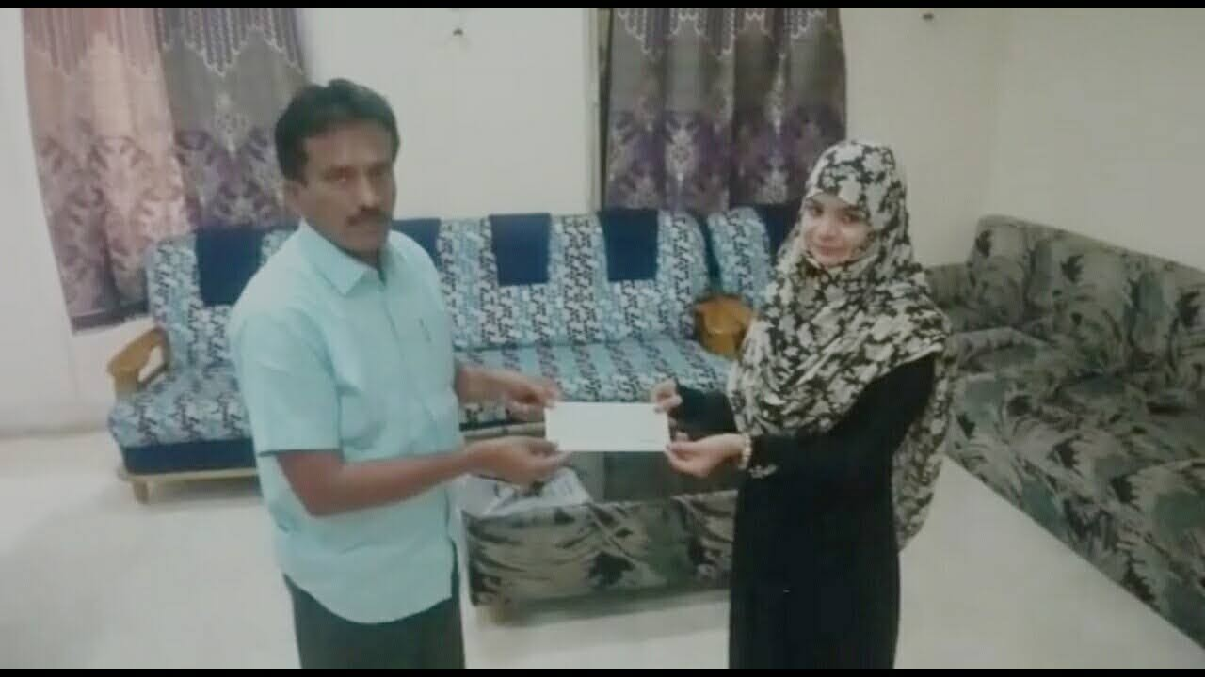
Kum.KATEEFA AFREEN B.A (HUP) GOT PRATIBHA AWARD IN THE YEAR 2016-2017
FROM
GOVERNMENT OF ANDHARA PRADESH
AND RECIVED A CHEQUE OF RUPEES 20,000/-

From
Dr. R Anand Reddy, Garu
Nodal College Principal
PVKN Govt. College
CHITTOOR

